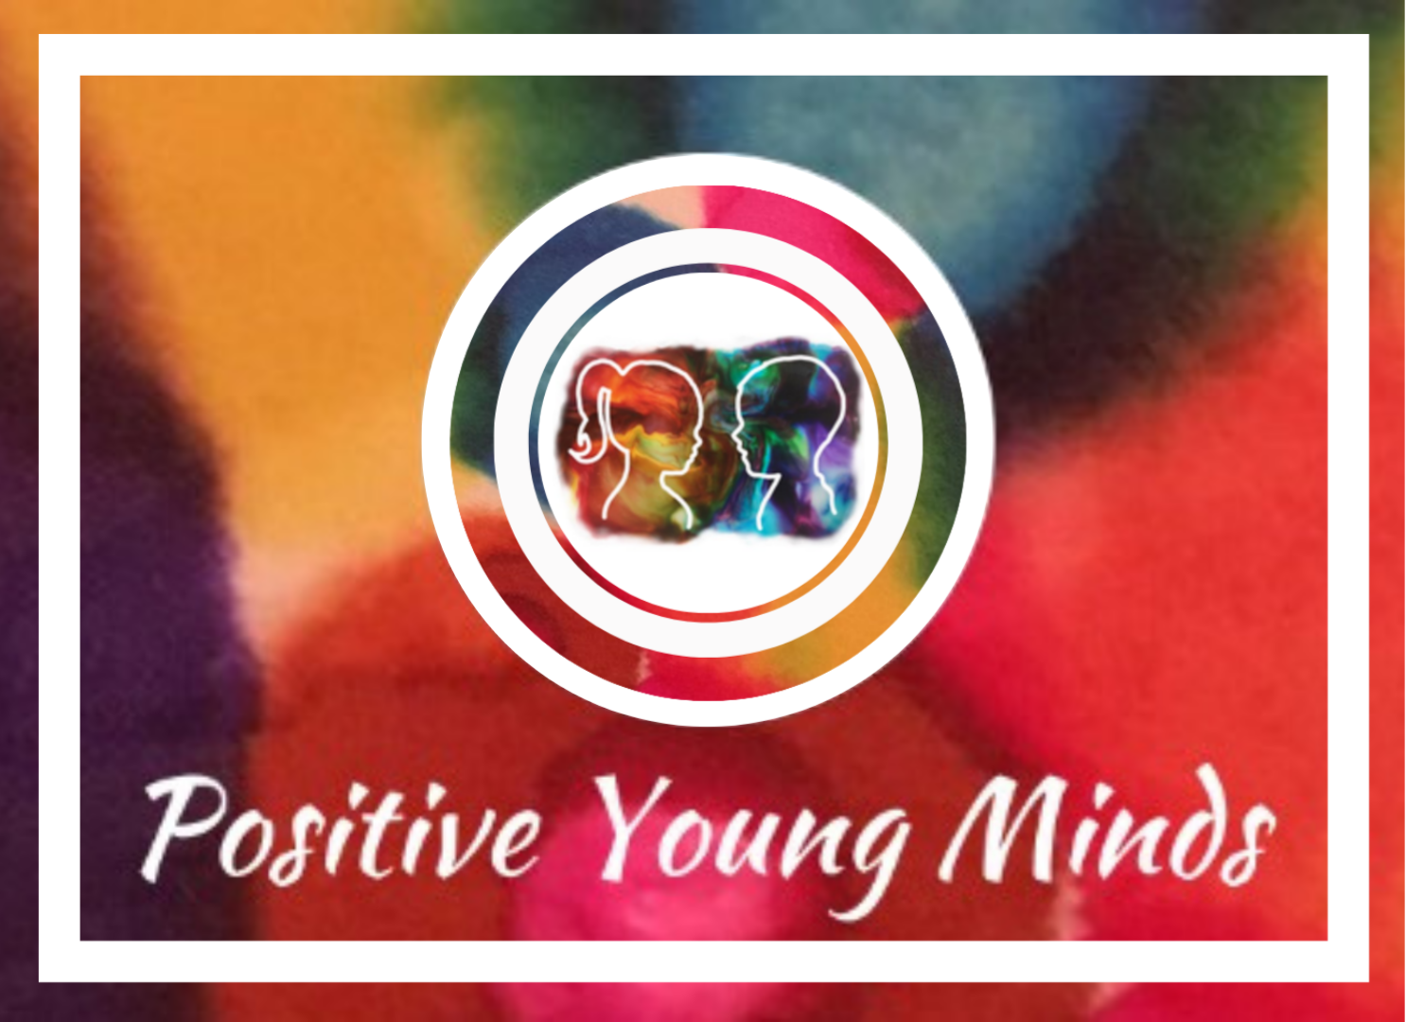
Evidence-Based Interventions and Useful Apps for the

Four Areas of SEND Need

(with primary and secondary versions for each area)

1. Communication and Interaction

Primary Interventions:
- NELI (Nuffield Early Language Intervention)
- Talk Boost (ICAN)
- Lego® Therapy
- Colourful Semantics
- Social Stories™ and visual timetables

Primary Apps/Tools:
- Speech Blubs
- Avaz
- Choiceworks
- Toca Life

Secondary Interventions:
- SCERTS Model
- Comic Strip Conversations
- Lego® Therapy (peer-led)
- Conversation Club (adapted Speech and Language programmes)

Secondary Apps/Tools:
- Proloquo2Go
- Talking Mats
- Otter.ai

2. Cognition and Learning

Primary Interventions:
- Precision Teaching
- Toe by Toe / Power of 2 / Plus 1
- SNIP Literacy Programme
- Nessy Reading and Spelling

Primary Apps/Tools:
- Nessy Learning
- GraphoGame
- DoodleMaths / DoodleEnglish

Secondary Interventions:
- Overlearning & Spaced Retrieval Practice
- C-Pen Reader
- Catch Up Literacy / Numeracy

Secondary Apps/Tools:
- Read&Write by TextHelp
- OneNote Learning Tools (Immersive Reader)
- Ghotit Real Writer

3. Social, Emotional and Mental Health (SEMH)

Primary Interventions:
- Zones of Regulation
- Thrive Approach
- Emotion Coaching
- ELSA (Emotional Literacy Support Assistant)
- The Feelings Furballs – SEMH (compliments ZofR or stand alone YR-Y6 and beyond) Primary Apps/Tools: https://amzn.to/3GlXtOY
- Breathe, Think, Do with Sesame
- Chill Panda
- Mindful Gnats
- GoNoodle

Secondary Interventions:
- CBT-based interventions (e.g. FRIENDS Programme, Think Good Feel Good)
- Check-in/Check-out Systems
- The Feelings Furballs – SEMH (SEND)
- Peer Mentoring Programmes

Secondary Apps/Tools:
- Mood Meter
- Smiling Mind
- Headspace for Teens
- Woebot

4. Sensory and/or Physical Needs

Primary Interventions:
- Sensory Circuits
- Sensory Diets (OT-guided)
- Fine and Gross Motor Skills Interventions
- MOVE Programme (motor development)

Primary Apps/Tools:
- Sensory Light Box
- GoNoodle
- Breathe, Think, Do with Sesame
- Tappy Tap (routine tracker)

Secondary Interventions:
- Individual Sensory Profiles (based on OT assessment)
- Adapted PE Programmes
- Regulation Zones Check-Ins

Secondary Apps/Tools:
- Seeing AI
- Be My Eyes
- PhysiApp
- Sensory App House Collection

Brought to you by www.positiveyoungmind.com
Find all my webinars here: https://positiveyoungmind.com/shop/
Also, my SENCO freebies: https://positiveyoungmind.com/senco-resources/

