SEND folder Contents
(One subject divider per child)
Contents:
1. SEN class Profile and data
2. Initial concerns
3. Consistent Improvement Plans (behaviour)
4. EHCP children:
• One page profile (latest)
• One planning (latest)
• Annual Reviews
• EHCP
• Specialist teacher/Ed Psyc reports
• Provision map

3. Wave 3 (one plans/IEPs, provision maps and OPP)
• One page profile (latest)
• One planning/IEP (latest)
• Specialist teacher/Ed Psyc reports
• Provision map

4. Wave 2 (OPP)
• One page profile (latest)
• One planning (latest)
• Specialist teacher/Ed Psyc reports
• Provision map

SEND intervention records and SEND resources in separate folders

Intervention Folder Contents

- Class SEND overview

- MAT Intervention booklet

- Intervention sheet masters

- Before and after tracking masters e.g.
- 100 first words read and spell
- How I feel about learning questionnaire
- SEAL grids

- Subject divider for each child to record interventions.
- Each intervention to be recorded using sheets provided and put in each child’s section.
- For S&L interventions, please add their speech and language target document at the front of their section and annotate when objectives are worked on and date when achieved.

Please note, catch-up/precision teaching interventions are in a separate catch up folder and IDL tracking is online.

Class resource folder contents
- Quality First Teaching (HQT) guide for each area of difficulty
- Overview of school resources/strategies/ SENCO assessment support
- Initial teacher concern form
- One planning/IEP guidance
- What’s working well sheet (to use with parents)
- How to write/amend One Plans/IEPs
- Staff training notes
- General class resources including:
- Mindmaps
- Personal targets/pupil passport
- Equipment needed for lessons
- Now and next sheets
- 100/200 first words read and spell
- Help cards
- Resources for SEMH/behaviour including:
- Zones of Regulation
- Comic strip converser
- Friendship formula
- Behaviour support and reward sheets
- Emotional scales
- How does your engine run?
- Resources for literacy difficulties/dyslexia including:
- Spotting persistent literacy difficulties (Dyslexic tendencies)
- Alternatives to writing ideas + writing strategies
- Colourful semantics (adapted for Rainbow Writing colours)
- Word Wizard
- Story planning resources
- Resources for number difficulties/dyscalculia including:
- Numicon resources
- Maths mat
- Resources for Speech and Language
- Identifying SaL difficulties
- Elklan techniques
10. Resources for ASD
- General notes and staff training notes
11. Resources for visual and hearing impairment
- General notes and staff training notes
12. Other

I hope you liked this free resource!

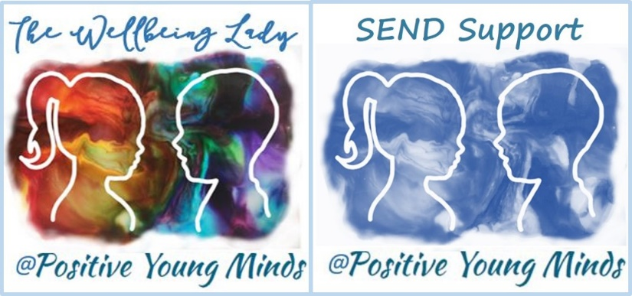

Lynn How
MA NASENCO NPQH
Educational Consultant

Find me at:
www.positiveyoungmind.com
Email: positiveyoungminds@outlook.com
@Positive_Y_Mind (Twitter)
Positive_young_minds (Instagram)
www.facebook.com/PositiveYoungMind
…. and for free teacher support
www.facebook.com/groups/coachingforteacherwellbeing

… also like and subscribe to my YouTube (example clips above)
https://www.youtube.com/channel/UC9egtRvu5XTiwKPPqLQ-VgQ
Support options include:
- Life, career and everything coaching.
- Bespoke school wellbeing packages.
- Bespoke SEND support and training for schools, teachers and parents.
Please refer to my website for details:
https://positiveyoungmind.com/send-wellbeing-consultancy/

Or just PM me

