Intervention record sheet (1 child)
Date: Session title:
Adult: Child:
Intended outcomes:

Resources used:

Session 1 date:
notes:

Session 2 date:
notes:

Session 3 date:
notes:

Session 4 date:
notes:

Any other comments/reflections:

Further action (e.g. shared with CT/FLO/SENCO/concern sheet)

Intervention tracking sheet (1 per child per half term)
Pupil name:_____________________ Intervention: _________________________ term: ________________
Date | am | pm | Comment
Codes:
- Very engaged, good learning this session
- Engaged, learning has taken place
- Somewhat engaged, some learning has taken place
- Not engaged, little learning has taken place

1
½ termly evaluation of intervention:

Next steps:

Date | am | pm | Comment

Any other comments:

www.positiveyoungmind.com
2

Intervention record sheet (group)
Date: Session title:
Adults:
Children:
Intended outcomes:

Resources used:

pupil names:
Notes:

Any other comments/reflections:

Further action (e.g. shared with CT/FLO/SENCO/concern sheet):

www.positiveyoungmind.com

I hope you liked this free resource!
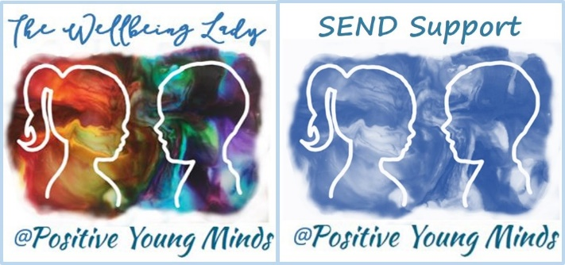

Find me at:

Lynn How
MA NASENCO NPQH
Educational Consultant

www.positiveyoungmind.com
Email: positiveyoungminds@outlook.com
@Positive_Y_Mind (Twitter)
Positive_young_minds (Instagram)
www.facebook.com/PositiveYoungMind

…. and for free teacher support: www.facebook.com/groups/coachingforteacherwellbeing
… also like and subscribe to my YouTube: https://www.youtube.com/channel/UC9egtRvu5XTiwKPPqLQ-VgQ
Support options include:
- Life, career and everything coaching.
- Bespoke school wellbeing packages.
- Bespoke SEND support and training for schools teachers and parents
Please refer to my website for details:
https://positiveyoungmind.com/send-wellbeing-consultancy/

Or just PM me

