Whole school approaches (ongoing where needed throughout the year)
What? | Why? | Who? children | Who?  Adults | Notes
Whole school regulation strategy | To use the colours to identify emotions and use the tools provided to regulate them. See classroom display. | Whole class | All adults in school
Growth mindset | Increased confidence and willingness to tackle challenges. | Whole class | All adults in school
Positive and nurturing ethos of the school | To feel safe and supported in school. | Daily nurturing | All adults in school
Pre-teaching | To scaffold new learning or vocabulary | As directed by teacher | LSA
Literacy difficulty/dyslexia-friendly environment | To enable all children to find it easier to access the curriculum. See classroom checklist (displayed in each class). | All | CT to lead
Learning Mentor | Children to have ½ termly 1:1 conference on how they are doing and moving learning forward. Some children may have this more regularly. | All | CT to lead
High-quality teaching Classroom Expectations
Differentiated/  scaffolded planning | To be able to access all lessons. If a pupil is working > 2 years below, discuss personalised learning with SENCO. | All with additional needs. | Class teacher
Daily verbal feedback to move on learning | Immediate feedback to support learning. | CT to lead | Class teacher/  LSA
Communication between CT & LSA | Interventions communicated and fed into planning | Specific children. | Class teacher/  LSA
High-quality scaffolding | The usual resources which allow HQT such as visuals, word banks, question stems, manipulatives etc. | Specific children. | Class teacher/  LSA
-Brain breaks  -Now/next/then board  -Visual timetable. | To support children with their concentration/SEMH/scaffolding needs | Specific children. | Class teacher/  LSA
Daily reading | To support word recognition and comprehension for any child significantly below ARE. 3 x weekly for just below ARE. See individual pupil checklists. | All unless ARE | Class teacher/  LSA
Whole school provision for ______________________ Class _________ Date ____________

I hope you liked this free resource!
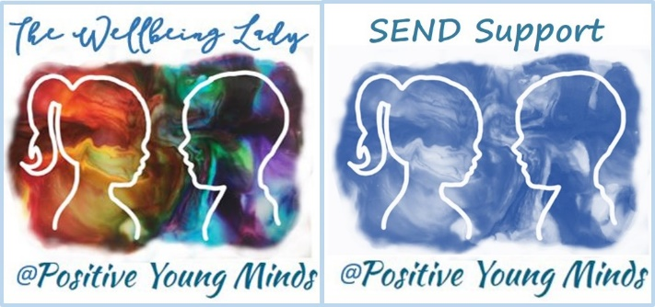

Find me at:

Lynn How
MA NASENCO NPQH
Educational Consultant

www.positiveyoungmind.com
Email: positiveyoungminds@outlook.com
@Positive_Y_Mind (Twitter)
Positive_young_minds (Instagram)
www.facebook.com/PositiveYoungMind

…. and for free teacher support: www.facebook.com/groups/coachingforteacherwellbeing
… also like and subscribe to my YouTube: https://www.youtube.com/channel/UC9egtRvu5XTiwKPPqLQ-VgQ
Support options include:
- Life, career and everything coaching.
- Bespoke school wellbeing packages.
- Bespoke SEND support and training for schools teachers and parents
Please refer to my website for details:
https://positiveyoungmind.com/send-wellbeing-consultancy/

Or just PM me

