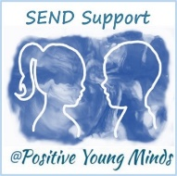
Individual Pupil learning walk template

Name | Class | PPG | need | Notes – comment on HQT, EHCP provision, inclusion strategies etc.

