Primary School One Plan
March 22 – July 22 Please change the date!
Name: | DOB | Year: | Class Teacher/SENCO | Pupil Profile:
SAMPLE | Check | Check | ***/*** | This section should provide an overview of the child’s need, provision and resources e.g. laptop, safe space (including positives!)  *** is a friendly member of the class who is always willing to help out and is the first to help a peer who is upset.  Extra support needed:  - *** sometimes struggles to regulate his emotions when he is frustrated, resulting in difficulty concentrating or needing to use a ‘safe space’  - *** often has difficulty retaining new concepts and sometimes has extra support from an LSA  - For *** reading is a particular area for development and he regularly plays phonics games and undertakes daily reading with an adult.  Resources allocated: laptop, safe space  Also, refer to provision map for more details
Class: | LA: | SEND phase | Main Diagnosis / Difficulty  SENCO to add (teachers don’t touch!)
Check | Yes | One plan (3) | ADHD
Reports: | Please add any new reports given to you since the last one plan which should be in your folder e.g. Provide/ SaLT  NHS - Dr A 20.07.20 ADHD (medicated add medication details)  SALT – Mrs B 7/7/22 assessment

INDIVIDUAL SEN TARGETS
Outcomes (by end of the key stage)  Directly from EHCP if applicable. | SMART targets  These need to be specific and measurable | Success Criteria / who / resources needed  Please annotate ‘live’ provision maps on share point.  (LSAs as well)  Review in green | Progress towards target
Communication and interaction  To apply his language skills so that he can:  - Express thoughts, ideas and feelings clearly  - Follow the language of the classroom  - Contribute to whole class discussions and group work appropriately.  To use social skills so that he can:  - Make and maintain appropriate peer friendships  - Contribute appropriately with social conversations and situations | - To name and understand 2 emotions/feelings from each of the Zones of Regulation.  - To use feelings fans regularly in lessons to support mood regulation.  - To discuss something in a group of 3 with LSA support (listen to another child’s comment and add 1 comment to the discussion).  Cross out achieved targets and write achieved when new targets are set, add a date.  Please refer to SaLT reports for SaLT targets and ensure they are up to date. | These should be strategies and what success looks like, not more objectives.  - By using Social Stories/Talkabout/ smart thinking he will be supported with classroom issues.  - Daily support with ZofR with LSA  To help him to succeed in this he will receive:  - Opportunities each week to spend time playing and working with other children, with adult support to ensure success.  - Now/next/then board  - Brain breaks  - Visual timetable.  - Short and clear instructions in simple language.  - Additional verbal/physical prompts to ensure listening before adults give instructions.  - Understanding will be carefully monitored.  - To repeat instructions to an adult before starting a task. | Each short term target needs to be reviewed to obtain information from the provision map.  Autumn:  Spring:  Summer:
Cognition and learning  To have functional literacy skills (age 9 reading) to access the next stage of education.  To have functional number skills (age 9) to access the next stage of education. | - To develop phonics skills so that he is confident with the split vowel sounds e.g. e_e, a_e, i_e for 80% of 5 letter words.  - To read the keywords: other, people, because. (current score 125/200)  Be specific about which letters/ times tables/words children are focusing on. Look below for a Smart target reminder: | - Regular support and prompting  - Clearly scaffolded activities  - Precision teaching 5xweekly  - Daily phonics support (small group LSA)  - Daily reading  - Class LSA small group support in English lessons 1:4 | Autumn:  Spring:  Summer:
Social, Emotional and Mental Health  To have the self-regulation skills needed for a successful secondary transition. | - To identify triggers to being in the yellow zone (with adult support)  - To begin to self-regulate while in the yellow zone with adult support. | - Daily ZofR support with class LSA (10 minutes + daily)  - Self-regulation mat of possible activity choices.  - Develop strategies for using the mat.  - Safe space near the classroom.  - Specialist teacher input requested. | Autumn:  Spring:  Summer:
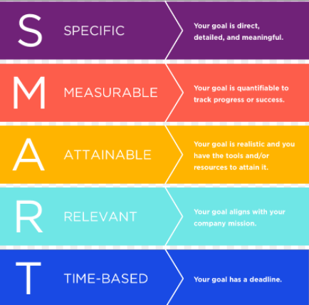

I hope you liked this free resource!
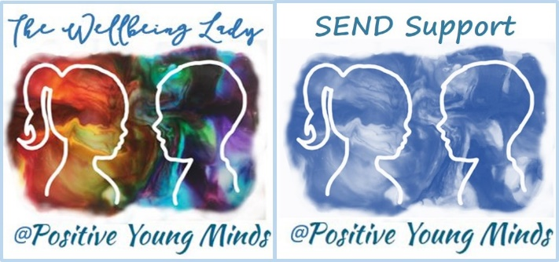

Find me at www.positiveyoungmind.com
Email: positiveyoungminds@outlook.com
@Positive_Y_Mind (Twitter)
Positive_young_minds (Instagram)
www.facebook.com/PositiveYoungMind

…. and for free teacher support: www.facebook.com/groups/coachingforteacherwellbeing
… also like and subscribe to my YouTube: https://www.youtube.com/channel/UC9egtRvu5XTiwKPPqLQ-VgQ
Support options include:
- Life, career and everything coaching.
- Bespoke school wellbeing packages.
- Bespoke SEND support and training for schools teachers and parents
Please refer to my website for details:
https://positiveyoungmind.com/send-wellbeing-consultancy/

Or just PM me

