Model SEND Register
This is a regularly changing document, assessed by the SENCO on a regular basis. Last updated 2/2/22
Upgrade potential highlighted in red | Downgrade potential highlighted in green | Highlighted = need to add to register on SIMS/Tracking system | 4 –EHCP | 3+ Applied for an EHCP unsuccessful or pending (Still SEN support 3) | 3 - SEN support (one plan + OPP) | 2 - One Page Profile only
Name |  | Year | Class | PPG | Stage of Need  Phase | Category of Need + Info
 | Harry M | 3 | A |  | 4 | SLCN CL | SaLT re cleft, personalised curriculum with 1:1 morning. ADHD, S self-regulating but needs an adult to support regulation.
 | Amelia S | 3 | A |  | 3 | ASD | Difficulty self-regulating and leaves the classroom. Class LSA supporting. Parents on board. EP requested Jan 22. Potential EHCP application.
 | Logan L | 3 | A | Y | 2 | NSA | NSA low (working at the start of Y1)
 | Esme P | 3 | A |  | 2 | SLCN | SLCN concerns have been referred to NHS SaLT
 | Leo A | 3 | A | Y | 2 | SEMH | SEMH concerns – Lego group started March 22
 | Mia P | 3 | B |  | 4 | ADHD/ASD | Personalised curriculum, safe space, SEMH concerns (pastoral team involved) EP appointment 31.3.22
 | Ronnie T | 3 | B | Y | 3+ | MLD | Applied for EHCP 10.12.21 currently appealing decision. 1:1 LSA am
 | Kieron K | 3 | B |  | 2 | SLCN | SLCN concerns have been referred to NHS SaLT
 | Year 3 = 2@3 , 4@2 + EHCP 2 = 8
Total SEND: One Page Profile only: One plan: EHCP and One plan:

Key  - Specific learning difficulties (SpLD)  - Moderate learning difficulty (MLD)  - Global developmental delay (GDD)  - Severe learning difficulty (SLD)  - Profound and multiple learning difficulties (PMLD)  - Speech, language and communication needs (SLCN)  - Social, emotional and mental health (SEMH)  - Autistic spectrum disorder (ASD)  - Visual impairment (VI)  - Hearing impairment (HI)  - Multisensory impairment (MSI)  - Physical disability (PD)  - ‘SEN support’ but no specialist assessment of the type of need (NSA) | Main areas  - Communication and interaction (CI)  - Cognition and learning (CL)  - Social, emotional and mental health (SEMH)  - Sensory and/or physical needs (S/P)

Watch list (not on register)
Name | Year Group | Class | Stage of Need | Category of need/notes
Emily K | 4 | B | 1 | NSA – 1.5 years below ARE
Ava P | 3 | C | 1 | SLCN concern – referred to SaLT
Archie M | 5 | D | 1 | Initial concern re working memory
Removed from the register due to progress and no longer meeting SEND Criteria
Name | Year | Class | Category of Need | Reason for removal from the register
Oscar H | 3 | NHG | HI | Signed off, hearing returned to normal. Watch out for glue ear.
Riley M | 5 | V | SEMH | Home settled down, SEMH much improved. Making good progress.
Kory P | 5 | V | NSA | Does not require SEND intervention. Progress made
Georgia D | 5 | H | NSA | Does not require SEND intervention. Progress made
Other:
Name | Year | Class | Notes
Maya H | 5 | E | New to UK Jan 22 EAL – no apparent SEND concerns

I hope you liked this free resource!
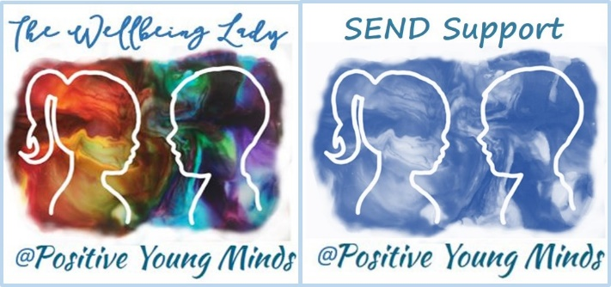

Find me at:
www.positiveyoungmind.com
Email: positiveyoungminds@outlook.com
@Positive_Y_Mind (Twitter)
Positive_young_minds (Instagram)
www.facebook.com/PositiveYoungMind

…. and for free teacher support: www.facebook.com/groups/coachingforteacherwellbeing
… also like and subscribe to my YouTube (example clips above) https://www.youtube.com/channel/UC9egtRvu5XTiwKPPqLQ-VgQ
Support options include:
- Life, career and everything coaching.
- Bespoke school wellbeing packages.
- Bespoke SEND support and training for schools teachers and parents
Please refer to my website for details:
https://positiveyoungmind.com/send-wellbeing-consultancy/

Or just PM me

