Spring 22- Individual Provision Map
Photo
Name: Alfie Year: 5

This document outlines support received in addition to high-quality teaching and universal provision.
Class: A | Level of Needs:  Phase 3 One plan | Date initiated:  Sept 21 | Date for Review:  Monthly
Overview of additional needs
Literacy Skills/LDD | Numeracy skills/LDD | Speech and Language/SALT  NHS | Fine and/or Gross motor skills/OT
Alfie is working > 3 years behind ARE in reading and writing.  Alfie struggles with reading and spelling and is working on the consolation of his first 100 words for reading and first 25 words for spelling.  Alfie finds it difficult to structure a 5-word sentence.  Resources provided: Reading pen, blue overlay. | Alfie is working > 3 years behind ARE in number work.  He is working approximately 1 year behind ARE in shape work.  Resources provided: Usual HQT scaffolding resources | Alfie receives 1 hour every 3 weeks of NHS SaLT as well as weekly 3 x 10 minute LSA SLCN sessions.  Alfie struggles to follow instructions that contain concepts such as directions, location and time.  Alfie sometimes struggles to understand and retain complex new vocabulary for his core subjects  Resources provided: speech therapist, Lego group intervention. | Alfie finds letter formation difficult and completes dough gym and handwriting interventions.  He has access to a laptop for his written work as well as speech-to-text technology.  Resources provided: laptop
Sensory needs | Attention and Listening | Social Interaction | Behaviour and emotional
No identified needs | Alfie finds it difficult to concentrate for longer than 5 minutes.  Resources provided: Usual HQT scaffolding resources | No identified needs | Alfie can get very frustrated when he is in class and is having difficulty with his work.  Resources provided: Usual HQT scaffolding resources and extra LSA support as required.

Provision | Target (from one plan or broken down further) | Frequency, length, group size. | Who? | Start  Date | Outcomes: (Achieved, Partially Met, Not Met)
Daily reading | To answer basic questions from a red band text (where the answer is in the text). | Daily, 5 minutes 1:1 | LSA/CT | Sept 21 | Sept 22: Alfie keen to read to an adult. We have found that a blue overlay is helping his reading.  Oct 22:  Nov 22:  Dec 22:
Precision teaching | To show good progress linking to next 5 words reading: many, then, off, other, man  spelling: the, that, me, saw, | Daily, 5 minutes 1:1 | LSA | Sept 21 | Sept 22: Achieved spelling of ‘the’ and can read ‘man’ and ‘off’  Oct 22:  Nov 22:  Dec 22:
SaLT target work | To follow an instruction with an object and direction. E.g. put the red car on the left spot. | Weekly 20 minutes | SLCN LSA | Sept 21 | Sept 22: Although Alfie is keen, this is on a Friday afternoon and his energy levels are low. From next week, it will be Tuesday mornings.  Oct 22:  Nov 22:  Dec 22:
Specialist support e.g. Speech and Language, SENCO/FLO or external visitor Interventions

SaLT  Targets from SaLT report | Please refer to SaLT targets. | 1 hour every 3 weeks | SaLT | Ongoing | Sept 22: SaLT reports that Alfie is making good progress (refer to report)  Oct 22:  Nov 22:  Dec 22:
Lego group | To listen and follow a 2 part instruction. | Weekly 30 minutes | SENCO | Jan 22 | Sept 22: Alfie has been practicing asking peers to repeat their instructions more slowly. He has been challenged to try this in class.  Oct 22:  Nov 22:  Dec 22:

I hope you liked this free resource!
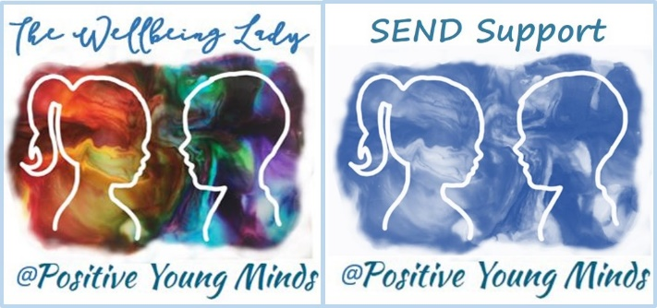

Find me at:
www.positiveyoungmind.com
Email: positiveyoungminds@outlook.com
@Positive_Y_Mind (Twitter)
Positive_young_minds (Instagram)
www.facebook.com/PositiveYoungMind

…. and for free teacher support: www.facebook.com/groups/coachingforteacherwellbeing
… also like and subscribe to my YouTube: https://www.youtube.com/channel/UC9egtRvu5XTiwKPPqLQ-VgQ
Support options include:
- Life, career and everything coaching.
- Bespoke school wellbeing packages.
- Bespoke SEND support and training for schools teachers and parents
Please refer to my website for details:
https://positiveyoungmind.com/send-wellbeing-consultancy/

Or just PM me

