Name of Pupil: |  | Date:
Class/Year Group: |  | Class Teacher:
Length of time at school: |  | Attendance:

Tick all concerns that apply:
Health |  | EAL |  | Other – please specify
PP? |  | Academic
Social |  | SEMH
Communication |  | Physical/Sensory

Pupil’s strengths:

Assess: Concerns -When did you first have concerns, any initial assessments done?
Please use High-Quality Teaching guidelines

What are the pupil’s needs/barriers to learning?
Communication and interaction

Cognition and learning

Social, Emotional and Mental Health

Physical and Sensory

Parent/carer view if informed:

Relevant assessment info and specific current attainment (ARE/Below/Working towards):

Other adults/agencies involved (e.g. behaviour lead, safeguarding lead, social care etc.):

Do: High-quality teaching on a classroom level - how have you adapted teaching to meet the pupil’s needs?  e.g. Now/next/then, brain break, visual timetable, safe space etc. |  | Review: What was the impact of these adaptions?
Action Taken | Date | Outcome/Impact | Date

For SENCO use only:

Plan: Further actions (to be completed by the SENCO and Class Teacher).
Do we need to make any referrals? What outcomes do we want to achieve?

Impact/Actions and Date

Do |  | Review
Action Taken | Date | Outcome/Impact | Date

I hope you liked this free resource!

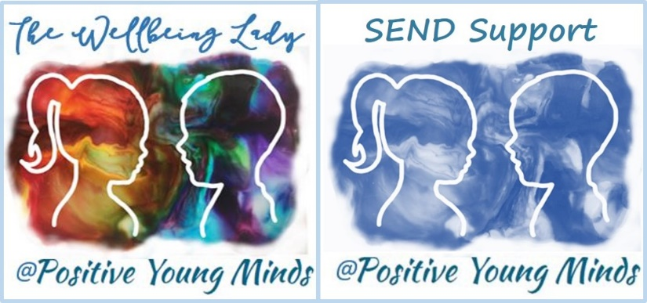

Lynn How
MA NASENCO NPQH
Educational Consultant

Find me at:
www.positiveyoungmind.com
Email: positiveyoungminds@outlook.com
@Positive_Y_Mind (Twitter)
Positive_young_minds (Instagram)
www.facebook.com/PositiveYoungMind
…. and for free teacher support
www.facebook.com/groups/coachingforteacherwellbeing

… also like and subscribe to my YouTube (example clips above)
https://www.youtube.com/channel/UC9egtRvu5XTiwKPPqLQ-VgQ

Support options include:
- Life, career and everything coaching.
- Bespoke school wellbeing packages.
- Bespoke SEND support and training for schools teachers and parents
Please refer to my website for details:
https://positiveyoungmind.com/send-wellbeing-consultancy/

Or just PM me

